Sprint 2 Materials

Equipo Grande



Anthony Bragg

Juliana Leano

Caroline Mejia

Daniel Morrison

Christopher Weeks

# Retrospective Summary

Overall, sprint two went well and we were able to accomplish most of the tasks that we set out to finish. Although we were a bit ambitious in creating our sprint backlog for sprint two, our idea was to work ahead in this sprint to leave room for minor adjustments that are bound to come up as the project nears completion. During this sprint, we used meetings much more effectively than in sprint one and each person had an improved sense of what everyone on the team was supposed to be doing and what they should be, or could be, working on at any given moment. Additionally, we used Jira more efficiently to keep better track of how our project was progressing by dividing tasks more into smaller, manageable chunks and being diligent in recording when each task was completed. Regarding procedure, we need to do a better job of accounting for the learning curve and including this curve in Jira by having tasks such as “Learn this language” or other similar tasks. Looking to the future, we need to add more to the product backlog; there are specific details that have not been accounted for. We did not meet our backlog goal of hiding elements on our navigation bar for employees since there were features that we decided to prioritize other features that we believed would improve the legibility of the pages. However, we were able to finish the bootstrap and css design for all the pages that the managers have access to.

# GitHub Release Link

# Product Backlog

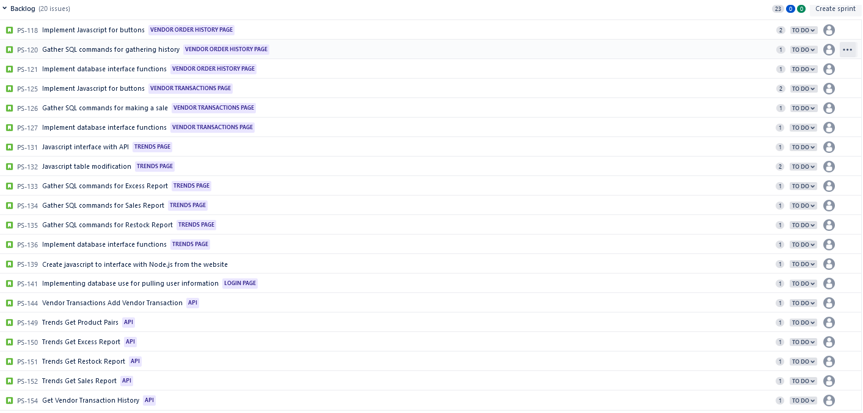

Sprint Backlog

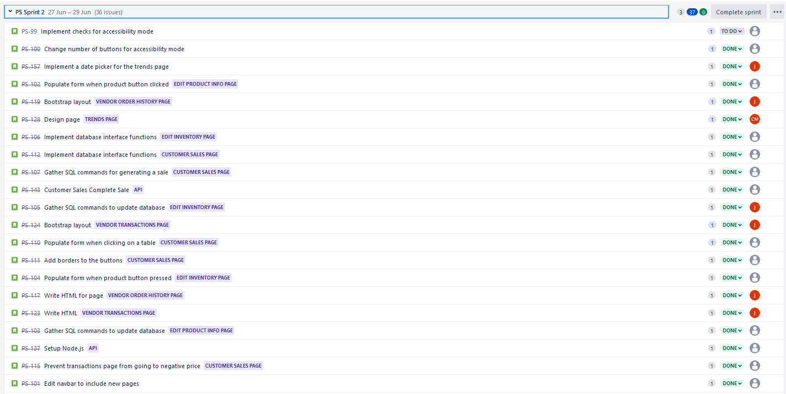

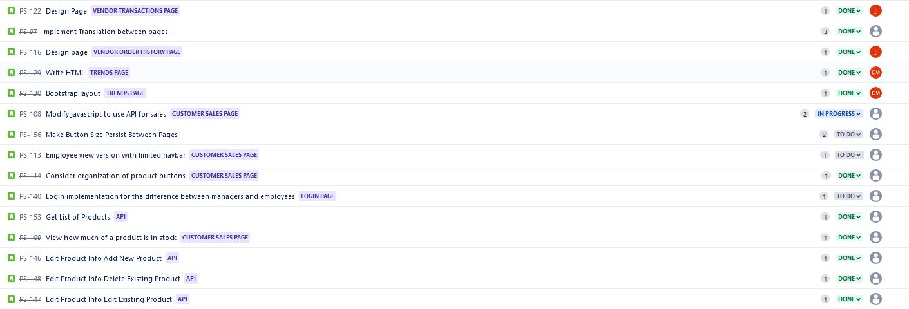

| Team Member | Sprint 1 | Sprint 2 | Sprint 3 |
| --- | --- | --- | --- |
| Anthony | 6 | 5 |  |
| Juliana | 4 | 8 |  |
| Caroline | 6 | 4 |  |
| Daniel | 10 | 5 |  |
| Chris | 5 | 8 |  |

# Burn-down Charts

Sprint 2 Burndown Chart:

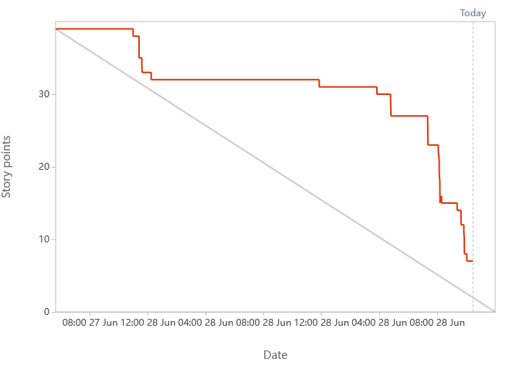

Project Burndown Chart:

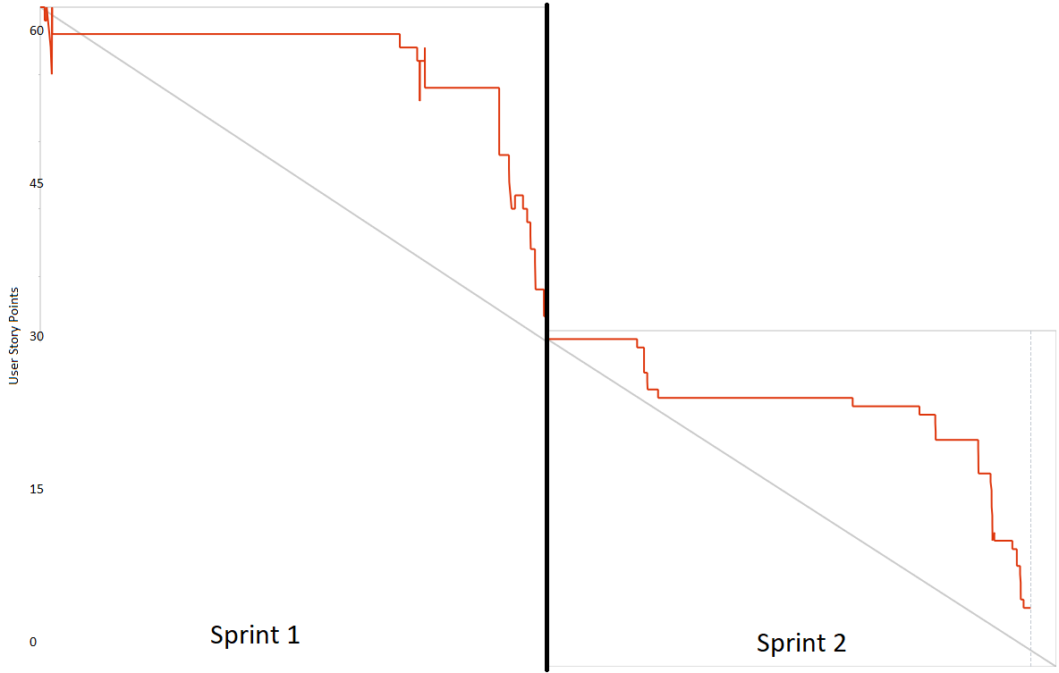

# Next Sprint’s SCRUM Meeting Schedule

* Scrum Meeting 1: 06/27/2022
* Scrum Meeting 2: 06/28/2022
* Scrum Meeting 3: 06/28/2022

Appendix 1: SCRUM Meeting Agendas and Minutes

SCRUM Meeting 1 for Equipo Grande Project 3

Prepared by: Anthony, Chris, Caroline, Juliana and Daniel

Meeting Date: 06/27/2022

## Meeting Attendees

1. Anthony
2. Chris
3. Caroline
4. Juliana
5. Daniel

## Meeting Agenda Items

* What did you finish last time, at the end of Sprint 1?
* What items are you working on today? (Assign tasks to team members)
* What roadblocks / challenges do you expect to encounter/ are facing already?

## Status Update Since Last Meeting

Accomplishments:

* Polished and finished up the front end of the sales page and its javascript functionality
* Button works now like the sizing on it cuz that was being weird
* Toggling the size stuff, um, idk that's probably it
* Refactored the transactions page into two sections and added price totals display

Tasks Completed:

| **Task Description** | **Assigned to** | **Completed? (yes/no)** |
| --- | --- | --- |
| Created form for adding an item to transaction | Anthony | Yes |
| Created buttons and functionality for add / edit and remove product | Anthony | Yes |
| Created interactable table of current sale | Anthony | Yes |
| Polish user experience for sales page | Anthony | Yes |
| Implement Google Translate API | Daniel | Yes |
| Fixed Button Responsive Resizing | Chris | Yes |
| Added Size Toggle Button | Chris | Yes |
| Refactored Transaction Page | Juliana | Yes |
| Added finishing touches to login page | Caroline | Yes |

## Before The Next Meeting

Plans:

* Create Node.js / Express.js API for sales, current inventory and edit product information.
* Create functions to great GET requests for API information

Task Assignments:

| **Task Description** | **Assigned to** |
| --- | --- |
| Write Node.js for sales | Anthony |
| Write SQL commands for the Node.js to run for sales | Anthony |
| Write javascript functions to GET information from the API for sales | Anthony |
| Write Node.js for current inventory | Chris |
| Write Node.js for edit product information | Daniel |
| Write SQL commands for the Node.js to run for edit product information | Daniel |
| Write SQL commands for the Node.js to run for current inventory | Chris |
| Design and write HTML for the new pages | Caroline |
| Implement Bootstrap for the new pages | Juliana |
| Fix interface inconsistencies (button auto-fills / negative numbers, etc.) | Juliana |

## Minutes from Previous Meeting

Last meeting, we finished Sprint 1 and began discussing plans for the next sprint. We decided that we need to complete the bootstrap and css for all the pages, and we decided that we need to implement that database to our pages.

SCRUM Meeting 2 for Equipo Grande Project 3

Prepared by:

Meeting Date:

## Meeting Attendees

1. Anthony
2. Chris
3. Caroline
4. Juliana
5. Daniel

## Meeting Agenda Items

* What did you finish last time, at the end of Sprint 1?
* What items are you working on today? (Assign tasks to team members)
* What roadblocks / challenges do you expect to encounter/ are facing already?

## Status Update Since Last Meeting

Accomplishments:

* The UI for the page has been improved quite a bit
* Node.js was set-up to host our pages
* Google Translate now persists between pages
* We have designed the future look of our application better, and re-organized it in GitHub

Tasks Completed:

| **Task Description** | **Assigned to** | **Completed? (yes/no)** |
| --- | --- | --- |
| Write Node.js for sales | Anthony | No |
| Write SQL commands for the Node.js to run for sales | Anthony | No |
| Write javascript functions to GET information from the API for sales | Anthony | No |
| Write Node.js for current inventory | Chris | No |
| Write Node.js for edit product information | Daniel | No |
| Write SQL commands for the Node.js to run for edit product information | Daniel | No |
| Write SQL commands for the Node.js to run for current inventory | Chris | No |
| Design and write HTML for the new pages | Caroline | No |
| Implement Bootstrap for the new pages | Juliana | No |

## Before The Next Meeting

Plans:

* Finish the unfinished tasks from yesterday
* Finish Sprint 2 Backlog
* Complete API for Sales, Products, and Inventory
* Interface with API for Sales, Products, and Inventory
* Finish writing HTML/CSS for Vendor Transactions, Vendor History, and Trends

Task Assignments:

| **Task Description** | **Assigned to** |
| --- | --- |
| Create a different interface for manager / cashier | Juliana |
| Update sales page with a quantity indicator | Daniel |
| Write Node.js and SQL commands for sales | Anthony |
| Created limited navbar for employee view | Caroline |
| Finish trends page (sidebar, graph, etc.) | Caroline |
| Finish HTML/Bootstrap for Vendor Transactions | Juliana |
| Update manager navbar with new page tabs | Caroline |
| Write Node.js and SQL commands for Edit Product page | Chris |
| Write Node.js and SQL commands for Edit Inventory page | Daniel |
| Change number of rows/columns of buttons for accessibility view | Chris |
| Make button size persist between pages | Chris |
| Finish API for Products | Chris |
| Write API for Inventory | Daniel |
| Write API for Sales | Anthony |
| Interface with API for Products | Chris |
| Interface with API for Sales | Anthony |
| Interface with API for Inventory | Daniel |

## Minutes from Previous Meeting

Yesterday it was planned that we would finish the back-end API and SQL for the make sale, products and inventory pages. In addition it was planned that our front end team would write and design pages and implement bootstrap for the trends and vendor history pages. The biggest impediment we foresaw was our lack of knowledge on how to use the node.js environment and working with the express and pg modules.